October 5-9, 2020

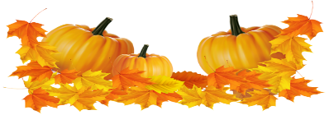
Nightly Homework
- Practice spelling & sight words
- Read 10-20 minutes
- Check/Sign Planners & Folders

Spelling Words
-tap -day
-lap -say
-map -may
-clap -play
-strap -stray
-too -will

Sight Words
-too -want
-what -will

Vocabulary
Math:
-compare -difference
-fewer -minus
-more -subtract
-subtraction sentence

Science
-motion -speed
-straight line -zigzag
-push -pull
-force -gravity
-back-and-forth
-round-and-round

This Week’s Skills/Themes
Phonics: spelling pattern -ap, -ay
Comprehension: Main Idea & Details
Language: Interrogative Sentences
Writing: Informational paragraph
Math: Subtraction concepts
Science: How objects move

**Spirit Day is Friday! Show your school
pride and wear a Heathrow shirt.

October 5-9, 2020

Nightly Homework
- Practice spelling & sight words
- Read 10-20 minutes
- Check/Sign Planners & Folders

Spelling Words
-tap -day
-lap -say
-map -may
-clap -play
-strap -stray
-too -will

Sight Words
-too -want
-what -will

Vocabulary
Math:
-compare -difference
-fewer -minus
-more -subtract
-subtraction sentence

Science
-motion -speed
-straight line -zigzag
-push -pull
-force -gravity
-back-and-forth
-round-and-round

This Week’s Skills/Themes
Phonics: spelling pattern -ap, -ay
Comprehension: Main Idea & Details
Language: Interrogative Sentences
Writing: Informational paragraph
Math: Subtraction concepts
Science: How objects move

**Spirit Day is Friday! Show your school
pride and wear a Heathrow shirt.

