October 19-23, 2020

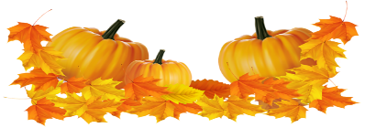
Nightly Homework
- Practice spelling & sight words
- Read 10-20 minutes
- Check/Sign Planners & Folders

Spelling Words
-grow -grill
-gray -try
-tray -trip
-treat -trash
-slow -plant
-give -get

Sight Words
-give -did
-get

Vocabulary
Math:
-count on
-doubles
-doubles minus one
-doubles plus one
-make a ten

Science
-motion -speed
-straight line -zigzag
-push -pull
-force -gravity
-back-and-forth
-round-and-round

This Week’s Skills/Themes
Phonics: Blends
Comprehension: Story Elements
Language: Sentence Structure
Writing: Use a topic & facts in a paragraph
Math: Addition Strategies
Science: How objects move

**Spirit Day is Friday! Show your school
pride and wear a Heathrow shirt.

October 19-23, 2020

Nightly Homework
- Practice spelling & sight words
- Read 10-20 minutes
- Check/Sign Planners & Folders

Spelling Words
-grow -grill
-gray -try
-tray -trip
-treat -trash
-slow -plant
-give -get

Sight Words
-give -did
-get

Vocabulary
Math:
-count on
-doubles
-doubles minus one
-doubles plus one
-make a ten

Science
-motion -speed
-straight line -zigzag
-push -pull
-force -gravity
-back-and-forth
-round-and-round

This Week’s Skills/Themes
Phonics: Blends
Comprehension: Story Elements
Language: Sentence Structure
Writing: Use a topic & facts in a paragraph
Math: Addition Strategies
Science: How objects move

**Spirit Day is Friday! Show your school
pride and wear a Heathrow shirt.

