October 12-16, 2020

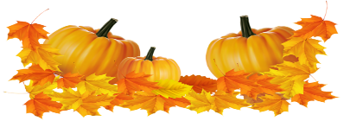
Nightly Homework
- Practice spelling & sight words
- Read 10-20 minutes
- Check/Sign Planners & Folders

Spelling Words
-man -pin
-chin -sit
-mop -hop
-not -hot
-but -frog
-any -came

Sight Words
-any -came
-but

Vocabulary
Math:
-count on
-doubles
-doubles minus one
-doubles plus one
-make a ten

Science
-motion -speed
-straight line -zigzag
-push -pull
-force -gravity
-back-and-forth
-round-and-round

This Week’s Skills/Themes
Phonics: VC pattern & same middle sounds
Comprehension: Reading strategies
Language: Context clues
Writing: Use information to answer questions
Math: Addition Strategies
Science: How objects move

**Spirit Day is Friday! Show your school
pride and wear a Heathrow shirt.

October 12-16, 2020

Nightly Homework
- Practice spelling & sight words
- Read 10-20 minutes
- Check/Sign Planners & Folders

Spelling Words
-man -pin
-chin -sit
-mop -hop
-not -hot
-but -frog
-any -came

Sight Words
-any -came
-but

Vocabulary
Math:
-count on
-doubles
-doubles minus one
-doubles plus one
-make a ten

Science
-motion -speed
-straight line -zigzag
-push -pull
-force -gravity
-back-and-forth
-round-and-round

This Week’s Skills/Themes
Phonics: VC pattern & same middle sounds
Comprehension: Reading strategies
Language: Context clues
Writing: Use information to answer questions
Math: Addition Strategies
Science: How objects move

**Spirit Day is Friday! Show your school
pride and wear a Heathrow shirt.

