Nov. 30-Dec 4, 2020
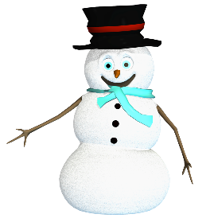
Nightly Homework
- Practice spelling & sight words
- Read 10-20 minutes
- Check/Sign Planners & Folders

Spelling Words
-chalk -chin
-chop -lunch
-shark -bath
-think -photo
-graph -what
-where -why

Sight Words
Review all Quarter 2 sight words

Vocabulary
Math:

-count back

Science
-stars -magnifier

This Week’s Skills/Themes
Phonics: Digraphs
Comprehension: compare &
Contrast character experiences
Language: inflected endings
Writing: Narrative writing
Math: Subtraction Strategies
Science: Observing Stars

**Spirit Day is Friday! Show your school
pride and wear a Heathrow shirt.

Nov. 30-Dec 4, 2020
Nightly Homework
- Practice spelling & sight words
- Read 10-20 minutes
- Check/Sign Planners & Folders

Spelling Words
-chalk -chin
-chop -lunch
-shark -bath
-think -photo
-graph -what
-where -why

Sight Words
Review all Quarter 2 sight words

Vocabulary
Math:

-count back

Science
-stars -magnifier

This Week’s Skills/Themes
Phonics: Digraphs
Comprehension: compare &
Contrast character experiences
Language: inflected endings
Writing: Narrative writing
Math: Subtraction Strategies
Science: Observing Stars

**Spirit Day is Friday! Show your school
pride and wear a Heathrow shirt.

