May 3-7, 2021

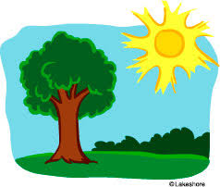
Nightly Homework
- Practice sight words
- Read 10-20 minutes
- Check/Sign Planners & Folders

Spelling Words
-mouth -house
-found -our
-out -cloud
-ouch -shout
-round -count
-were -would

Sight Words
-were -would

Vocabulary
Math:
-longest -shortest

Science
-offspring -similar

This Week’s Skills/Themes
Phonics: vowel digraph oo
Comprehension: Narrative elements
Language: pronouns
Writing: narrative writing
Math: Measurement
Science: Heredity

**Spirit Day is Friday! Show your school
pride and wear a Heathrow shirt.

May 3-7, 2021

Nightly Homework
- Practice sight words
- Read 10-20 minutes
- Check/Sign Planners & Folders

Spelling Words
-mouth -house
-found -our
-out -cloud
-ouch -shout
-round -count
-were -would

Sight Words
-were -would

Vocabulary
Math:
-longest -shortest

Science
-offspring -similar

This Week’s Skills/Themes
Phonics: vowel digraph oo
Comprehension: Narrative elements
Language: pronouns
Writing: narrative writing
Math: Measurement
Science: Heredity

**Spirit Day is Friday! Show your school
pride and wear a Heathrow shirt.

