May 17-21, 2021

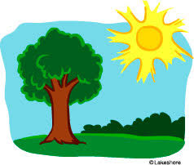
Nightly Homework
- Practice sight words
- Read 10-20 minutes
- Check/Sign Planners & Folders

Spelling Words
-boil -coin
-join -oil
-oink -point
-soil -voice
-boy -toy

Sight Words
Review ALL sight words

Science
-offspring -similar

This Week’s Skills/Themes
Phonics: Review phonics skills
Comprehension: Review reading skills
Language: review all grammar skills
Writing: review and practice writing skills
Math: Review all math skills
Science: Heredity

**Spirit Day is Friday! Show your school
pride and wear a Heathrow shirt.

May 17-21, 2021

Nightly Homework
- Practice sight words
- Read 10-20 minutes
- Check/Sign Planners & Folders

Spelling Words
-boil -coin
-join -oil
-oink -point
-soil -voice
-boy -toy

Sight Words
Review ALL sight words

Science
-offspring -similar

This Week’s Skills/Themes
Phonics: Review phonics skills
Comprehension: Review reading skills
Language: review all grammar skills
Writing: review and practice writing skills
Math: Review all math skills
Science: Heredity

**Spirit Day is Friday! Show your school
pride and wear a Heathrow shirt.

