December 7 - 11, 2020
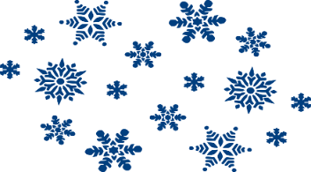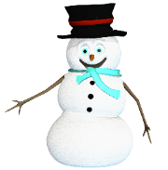

This Week’s Books/Themes (continued)
- Winter Holidays
- Fairy Tales & Fables

Nightly Homework
- Practice sight words
- Read 10-20 minutes
- Check/Sign Planners & Folders

Fairy Tale Vocabulary Words
(see handout for definitions)
-castle -crown
-king -magic
-prince -princess
-queen -spell
-wand -witch

Sight Words

Continue reviewing all Quarter 2 sight words

Vocabulary
Math:
-count back
-related facts

Science
-stars -magnifier
-moon -telescope
-sun

This Week’s Skills/Themes
Phonics: Digraphs
Comprehension: Identify the author’s reason
Language: singular and plural nouns/verb agreement
Writing: Informative writing
Math: Subtraction Strategies/related facts
Science: Observing Stars

**Spirit Day is Friday! Show your school
pride and wear a Heathrow shirt.

December 7 - 11, 2020

This Week’s Books/Themes (continued)
- Winter Holidays
- Fairy Tales & Fables

Nightly Homework
- Practice sight words
- Read 10-20 minutes
- Check/Sign Planners & Folders

Fairy Tale Vocabulary Words
(see handout for definitions)
-castle -crown
-king -magic
-prince -princess
-queen -spell
-wand -witch

Sight Words

Continue reviewing all Quarter 2 sight words

Vocabulary
Math:
-count back
-related facts

Science
-stars -magnifier
-moon -telescope
-sun

This Week’s Skills/Themes
Phonics: Digraphs
Comprehension: Identify the author’s reason
Language: singular and plural nouns/verb agreement
Writing: Informative writing
Math: Subtraction Strategies/related facts
Science: Observing Stars

**Spirit Day is Friday! Show your school
pride and wear a Heathrow shirt.

